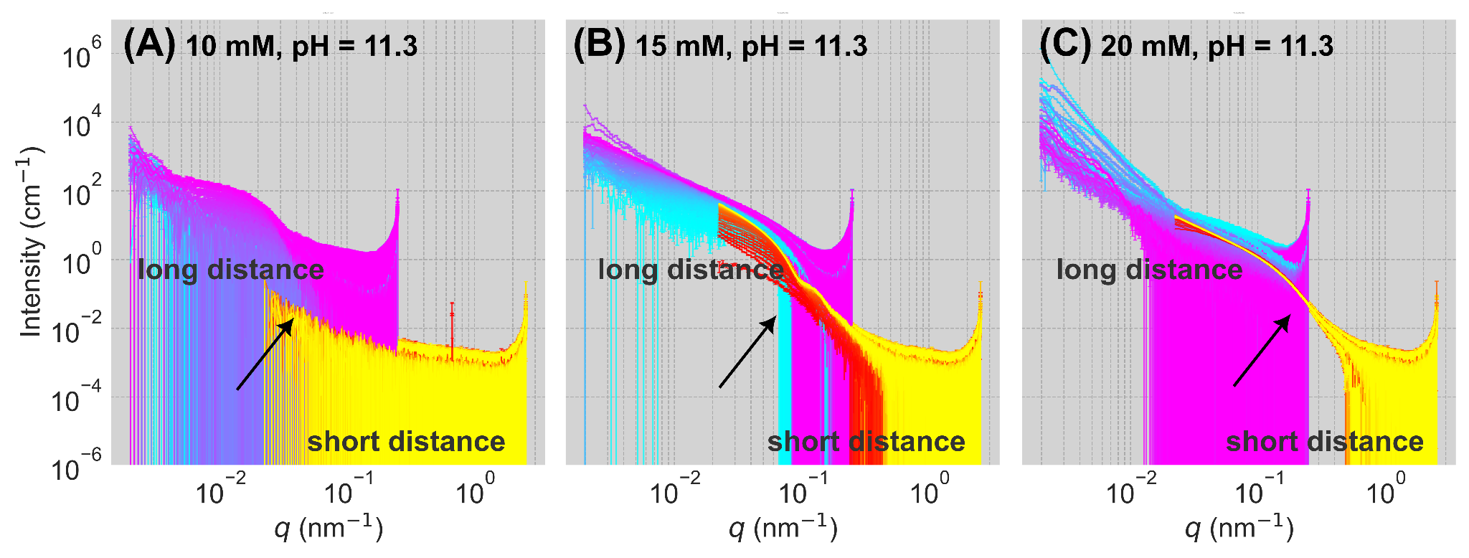

Figure 1. Time-resolved SAXS datasets from three concentrations of CaCO₃ at pH = 11.3. A) 10 mM, B) 15 mM C) 20 mM. The initial curve for all data sets corresponds to 0.060 s, with dt = ~0.015 s, and 350 frames (approximate since dt was non-linear). Thus, each presented date set represents ~5 s of the reaction. Arrows in each panel correlate the increase in intensity with the reaction progress. In each panel, two data sets from separate analogous experiments are plotted: “long distance” for the sample-to-detector of 30.7 m, and “short distance” for 3.0 m. Since the long and short distance experiments were independent of each other, only a limited overlap between the data sets was possible, especially for scenarios involving nucleation rather spinodal decomposition/phase separation (see the main text).

In Fig. 1 we are considering three different concentration regimes of CaCO₃: 10, 15 and 20 mM. Under stopped-flow conditions, these three concentrations lead to resoundingly different CaCO₃ “precipitation” routes. For low supersaturation (Fig. 1A), we observe a typical nucleation processes, which most likely leads to ACC. This is evidenced by several features in scattering. First, we see a gradual increase in intensity as the reaction progresses, where the very initial curves seem to contain primarily noise. This correlates with the notion of induction time and a nucleation barrier that needs to be overcome. Secondly, the observed scattering patterns later stages represent spheres of limited polydispersity, desribeable by a spherical form factor with a size distribution, and finite size in the range of ~200-300 nm, as observed for the “long distance” , and manifesting itself as noise for the “short distance”. Such scattering is typical for ACC in solution.
As the concentration is raised to 15 mM, the processes becomes more complex. On one hand it still involves structural motifs and trends, namely the polydisperse spheres, albeit significantly smaller than in (A), in the range of < 100 nm.. However in (B), in addition to these polydisperse sphere features we can also see an onset of the evolution of a fractal network visible through a characteristic q^{-D} dependence, with D~1.8. This network is infinitely large from the point of view of our SAXS experiment. We would interpret (B) as a hybrid scenario, in which nucleation happens concurrently with a phase separation process. Indeed, as the supersaturation reaches 20 mM in (C), the system reaches an energy-barrier free composition, for which no nucleation is observed. Instead, practically instantaneously (i.e. without evolution), small building units are formed, visible as a characteristic “knee bending” region at q ~ 0.1 nm⁻¹, for both long and short distance. The only evolution occurs at lower q values, for which the fractal network expands. This suggests that in the case of CaSO₃ the spinodal decomposition manifests itself in scattering as an infinitely large fractal network (D = 1.8) of constant size and invariable primary building blocks.

